User Manual for Blackjack Game

Cole Smolinski

1. Main Menu

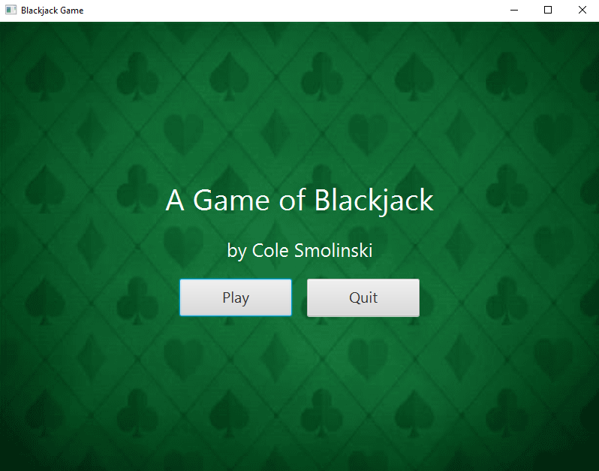

After starting the code, you will be greeted with the menu screen. From here, you can either start the game by pressing “Play” or exit out of the application by pressing “Quit”.

1. Betting Screen

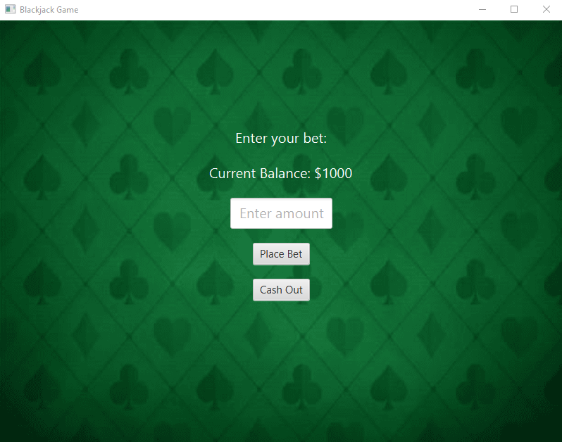

After pressing “Play”, you will be brought to the betting screen. Here you will be shown your current amount of money, starting with $1000. In the text box, you will be able to input the amount you want to bet. By pressing the “Place Bet” button, you will move on to the game screen. You can additionally “Cash Out” which will take the money you have and go to the results screen.

1. Game Screen

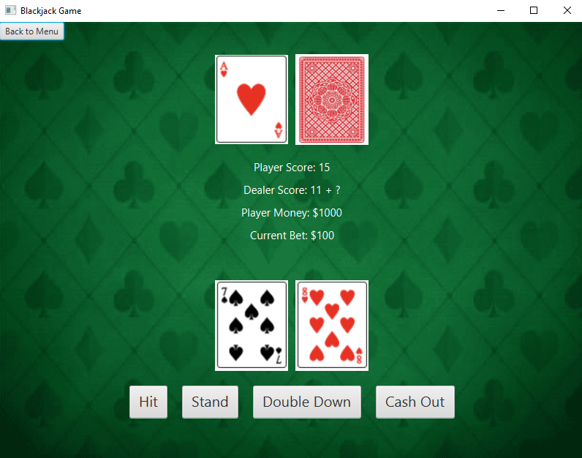

Once the bet has been placed, the game will begin. On the top is the dealer’s hand. The dealer will have one card showing and one card face down. In the middle will be the information regarding the round, such as your score, the dealer’s score, your money, and the bet you placed. Next is your hand, consisting of two cards that are dealt to you to start. Then are your control buttons, “Hit” will give you an additional card, “Stand” will end your turn and the dealer will take their turn, “Double Down” will double your bet, have you draw a single card, then end your turn, and “Cash Out” will bring you to the results screen. Your goal is to get as close to a score of 21 as possible without going over and beating your opponent’s score. The “Back to Menu” button will bring you back to the Main Menu Screen.

1. Results Screen

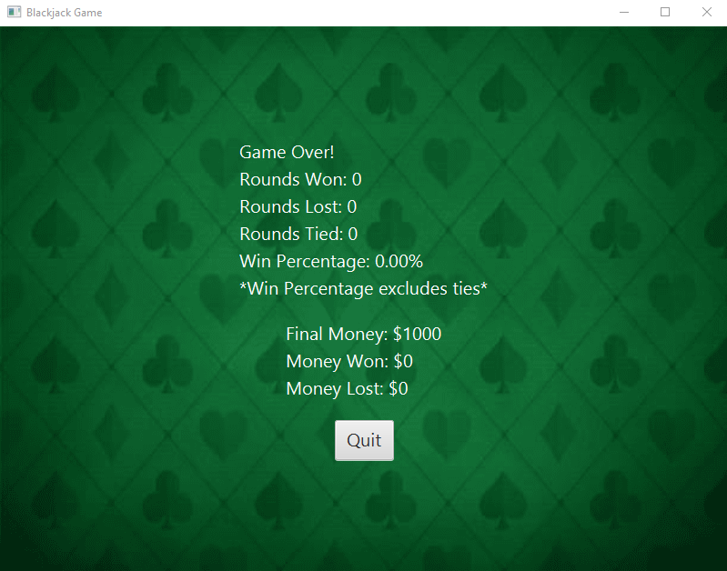

The Results Screen will show you your final stats for the game. It will start with the number of rounds won, lost, and tied, as well as a win percentage (the win percentage will exclude ties). Then it will show you the final amount of money you ended with when you either hit a “Cash Out” button or lost all of your money, as well as it will show you the amount of money you won and lost over the course of the game. Finally, the “Quit” button at the bottom of the screen will exit the application.